**RESUME**

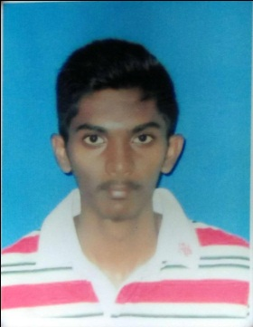Name : Baranitharan A/L Chandra Sekaran

Age : 23

Gender : Male

Address : Jalan Setia Impian U13/2n, Setia Alam,

40170 Shah Alam, Selangor

Nationality : Malaysian

Email : barani18650@gmail.com

**Career Objective:**

An electrical engineering student, knowledge in design and regulations of the field, seeks to work as an intern.

**Professional strengths:**

* Attention to detail with excellent communication skill
* Familiar with regulatory standard and procedures of electrical industry
* Knowledgeable in designing schematics and PCB
* Able to work cooperatively and a strong team player

**Education:**

* BEng (Hons) Electrical, currently completing 3rd year at Multimedia University Cyberjaya
* Foundation in Engineering
* SPM /O-level

**Projects involved:**

* Developed Arduino based automated mobile robot that is designed to monitor plant water level
* Involved in designing and building PCB motor driver circuits for low voltage electrical drive applications
* Designed AC to DC converter (controlled rectifiers)
* Designed and build 200W inverter circuit
* Planning and building of small scale solar power 500W generating system
* As project leader for 8051 Microcontroller project.
* As project leader for small industry lighting and power loads design.
* As a technical buddy advisor for FYP thermistor controlled cooling fan for LED driver circuit and smart electric meter.

**Skills:**

* Mathlab schematic
* Eagle PCB designing
* Multisim circuit designing
* Pspice software

**Extra-Curricular Activities Involvement:**

* Radio DJ for web based university radio broadcast.
* Head of sponsor department for cultural society event.
* Organizer for free car wash event in my university.
* Head of hostel community.

**Referee:**

* Lim Sin Liang as senior lecturer (Internship Chairperson, lab supervisor of CMSSP lab). Phone : 03-8312 5366
* [Faculty of Engineering](http://foe.mmu.edu.my/), [Multimedia University](http://www.mmu.edu.my/), Persiaran Multimedia, 63100 Cyberjaya, Selangor, Malaysia.